**LAB TEST-3**

SK JAVID AMAN

2503A52L17

**Q1:**

**PROMPT:**

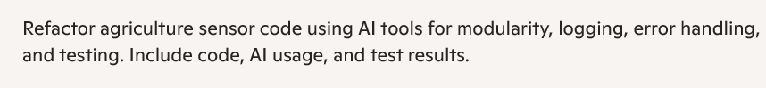**

**OUTPUT:**

**Observations:**

* Configures logging format with timestamps and severity levels.
* Pipeline execution is commented out for safe testing.
* Automatically runs unit tests when script is executed directly.

**Q2:**

**Observations:**

1. Class:

* Encapsulates farm plot metadata and sensor readings.
* Promotes object-oriented design for better scalability and reuse.

2.Method:

* Adds a new sensor reading with timestamp, temperature, humidity, and soil moisture.
* Uses dictionary format for simplicity and extensibility.
* Supports multiple readings per plot, enabling time-series analysis.